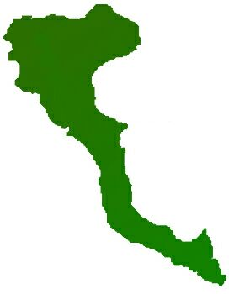

|  |  |  |  |  |
| --- | --- | --- | --- | --- |
| **Team: 3-D Protocol number: 7** | | | |  |
|  | | | |  |
| **Author: Pedro Arenas** | | **Date**: 26.01.2021 | |  |
| **Place:** MS Teams at 18.30 hrs | |  |
| **Participants:**  - Adnan, Muhammad  - Arenas, Pedro  - Shahid, Arsalan  - Ur Rehman, Mutee | | | |  |
| **Protocol of the meeting of 26 December 2020** | | | | |
| **Topic** | **Results** | | **Time** | |
| Project Decisions | Mr. Adnan will be team leader until next change | | 1 min | |
| Task State | Report creation and CMS documentation is still pending | | 1 min | |
|  | Mr. Adnan has completed the following tasks on front-end application:   * Details page for each film/movie * Menu * Create “Most awaited” components. * Resolved issues on the detail page. | | 10 min | |
|  | Mr. Shahid has completed the search functionality | | 2 min | |
|  | Mr. Arenas has completed integration between front-end and keycloak, and also between keycloak and Spring. Even though there won’t be any protected endpoint for prototype final version. | | 10 min | |
| Next Tasks | Mr. Adnan will work on these items this week:   * Add Review system * Search Page * Fix Logo issue. * Fix Menu items * Deploy on live for testing | | 1 min | |
|  | Mr. Arenas will create final report schema and add CMS documentation to it (pending from two weeks ago). | | 1 min | |